# A methodological framework for agricultural water allocation problem solving using Multistage Stochastic Programming techniques based on a Systematic Literature Review

***Juan Marques***[1]***1, Leonardo H. Talero-Sarmiento2, Henry Lamos1***

1 Industrial and Business Studies School, Industrial University of Santander, Cra. 27 #9 Colombia

*e-mail: [juan.marquez@correo.uis.edu.co](mailto:juan.marquez@correo.uis.edu.co)

e-mail: [hlamos@uis.edu.co](mailto:hlamos@uis.edu.co)

2 Industrial Engineering, Autonomous University of Bucaramanga, Av. 42 #48 – 11 Colombia

e-mail: [ltalero@unab.edu.co](mailto:ltalero@unab.edu.co)

## ABSTRACT

Water allocation represents an important and active research area today. It involves the problem of distributing water precisely and efficiently, considering the multiple factors that affect water demand, such as users' needs, economic effects, and regulatory policies. In agricultural activities, water management decisions are critical, as they can increase the risk and uncertainty of water availability and affect the proper allocation of available water recourse on usual farm practices. Therefore, this paper aims to construct a robust water allocation modelling framework for agriculture centered on reservoir managers and farmers considering uncertain conditions by systematically reviewing the existing literature on Multi-Stage Programming (MSP) and its applications considering the current growth of data-driven models. This study employed the PRISMA statement and Snowball Sampling Methodology using peer-reviewed case study articles in the 2000-2021 timespan. The results reveal a higher inclination toward using Two-Stage Stochastic Programming (TSP) instead of MSP in agricultural water allocation, considering TSP holds a low-cost but less flexible application than MSP. At the same time, hybrid optimization strategies represent better modelling approaches for uncertainty and problem constraint. This paper proposes a research agenda highlighting seven critical areas for future studies: addressing multiple optimization objectives, considering multiple uncertainty sources, exploring different uncertainty forms, including other external factors, developing more effective solution strategies, incorporating hybrid strategies, and integrating advanced technology solutions. Finally, this study provides a framework as a comprehensive understanding and guiding scheme for developing optimal agricultural water allocation plans under uncertain conditions, thus contributing significantly to sustainable water management in agriculture.

## KEYWORDS

*Methodological framework, Uncertain water allocation, Multistage stochastic programming, Inexact programming, Uncertain parameter modelling.*

## INTRODUCTION

Water resources allocation represents a matter of pivotal significance for the conservation of environmental ecosystems, productive development, and the country's socio-economic improvement, considering current rigorous policy regulations, the cost

of water resources, water demands, and limited water availability [1]–[3]. Efficient water resource allocation aims to provide the best water distribution schemes to fulfil every water user's requirements [4], ensuring [5]: water use security, water waste reduction, and social benefit achievement. Among users, irrigated agriculture is one of the leading agricultural water users representing the primary and most significant water consumer with an estimated use proportion of up to 70% of freshwater worldwide [6], [7]. Furthermore, agriculture plays a central role in food security achievement that requires increasing crop production to meet the growing population's future demand [8], [9] while supporting water resource-saving, environmental security, and socio-economic development. These primary concerns set more pressure on water use efficiency in agricultural practices than others [10], [11]. Nevertheless, developing an efficient allocation plan is a complex task regarding insufficient and irregular spatiotemporal water availabilities to outfit all the users and crop requirements, resulting from the constant increase in human activities, climate change, and population growth principally [12]–[15].

The allocation of water resources is significant for supporting proper agricultural water management, allowing decision-makers to benefit most. Allocation decisions answer which users (i.e., external users, farms, or crops) assign water resources to get the highest benefit while conserving natural resources in the system. Decision-makers (DM) conduct this activity regarding water availability, users demands, crop water needs, climate variability, crop yield or system net benefit maximization, and operations cost minimization [16], [17] while performing water productivity, the agricultural system benefit, and equity at maximum [18]–[21]. Thus, scientific literature indicates a long list of available strategies for proper agricultural water allocation based on optimization approaches [22], [23]. These approaches include Optimization techniques based on Mathematical Programming (MP) theories, different programming paradigms [24]–[28] and simulation optimization models that add simulation techniques to determine the crop requirements in the growth, production, and post-harvest periods [29]–[32] considering multiples inherent process in the crop system. Among these strategies, MP is one of the most representative and increasingly growling strategies lately [33], considering how it deals with water allocation problems integrating data-driven decisions related to multiple agroclimatic factors into an optimization scheme that allows obtaining the best decision under certain conditions empowering the decision-maker about how to manage properly the resources and cultivar conditions optimally.

Mathematical Programming provides several modelling approaches for water optimization and planning [34], considering multiple crops, various water sources, and different optimization objectives. In MP, authors apply several deterministic modelling strategies for supporting agricultural water allocation [35]–[37]. Nevertheless, proper water resources allocation presents complex difficulties due to random processes in regular activities that increase the risk in decision-making and add uncertainty to every decision step process, which traditional methods are usually not capable of dealing with [11], [22], [38]. These complexities arise mainly from multiple interactions between socio-economic factors, e.g., irrigation quota, benefits, water demands, or penalties [27], [39], hydrological factors, e.g., surface and groundwater availabilities, or precipitation [40], [41], and climatic factors such as temperature, radiation, wind speed, or humidity [42]. Inexact programming encompasses a compendium of programming techniques to face these uncertainties, allowing better reality modelling with satisfactory results in the agricultural water allocation domain [5].

Regarding today's rapidly advancing technological landscape, decision-making processes under uncertainty are increasingly supported by real-time and informed systems, enabling more accurate and reliable data-driven strategies. Under this angle, strategies such as Stochastic Programming (MSP and TSP) leverage the exponential growth of new technologies like high-performance computing, cloud computing, Big data analytics, Machine Learning, remote sensing, and real-time data integration through the Internet of Things (IoT) [43]–[47] to enhance decision-making processes, supporting the exploration of multiple scenarios, enabling data-driven and up-to-date decisions, and identifying patterns and relationships in data to provide robust solutions in uncertain conditions. Stochastic based strategies allow better planning schemes structuration for agricultural water allocation and irrigation considering uncertain parameters expressed as random variables [48], [49], allowing decision analysis, a better-supported, well-informed and risk-aware decision-making process, considering the multiple uncertain sources in the system firmly based on the availability and quality of associated parameter data [50].

TSP and MSP let an optimization scheme of two sets of decision-making stages. The first set carries first-stage decisions related to the beginning of the planning horizon, commonly called "here and now." Then, the second set holds the second (or more for MSP) stage decisions or "wait and see" decisions involving scenario-dependent variables. These last decisions associate random variables and commonly represent corrective actions or recourse decisions, allowing for adjusting the generated allocation and reducing the penalties in the water decision-making process [51]–[53]. Thus, the main goal of this study is to provide a collection of all the strategies based on TSP and MSP (and their corresponding derivations), supporting the building of a methodological framework formulation for agricultural water allocation under uncertainty. This study accomplished this task by developing a Systematic Literature Review (SLR) which allows for retrieving the highest amount of significant studies in a rigorous manner supporting analysing and summarizing relevant advances [54] in agricultural water allocation based on Stochastic Programming, considering stages in modelling formulation regarding the water principal decision-makers involved (i.e., reservoir managers and farmers only). Three guiding questions aim to undertake the SLR affording a higher analysis and better synthesis of the articles' revision [55] while providing a proper landscape to build the methodological framework:

* Q1: Which are the main crops analysed in selected studies?
* Q2: What are the primary sources of uncertainty decision-makers face and the most suitable techniques for uncertain parameter modelling?
* Q3: What main modelling strategies are related to MSP and the most common algorithms or solution methods?

## MATERIALS AND METHODS

A literature review is a valuable strategy in academic research that allows for mapping the field of study and identifying the importance of the topic and research gaps [56]. An SLR allows the construction of the methodological framework for water allocation in agriculture, considering an extensive literature review encompassing mainly case studies covering various disciplines related to water resources management, agronomy, economics, and social sciences. The SLR allows identifying existing methods, frameworks, and best practices related to agricultural water allocation providing a synthesis of the findings about concepts and critical components such as water availability, crop water requirements, modelling strategies, economic considerations, and environmental impacts. Then, this work applies the practical five-step framework for reviewing the scoping study to map the available literature, research gaps, and theories on the topic (Arksey and O'Malley, 2005) in conjunction with the PRISMA statement [58] and the Backward Snowball Sampling Methodology [59] to guarantee a better-supported and detailed scoping and SLR study covering a more significant number of results through a retrospective review. On the other hand, this work implements the concept-centric review [60] to answer the three guiding questions allowing an exhaustive SLR, using the Scopus and WOS databases regarding the scientific rigor, the comprehensive and peer-reviewed process for article publishing, and the number of sciences fields both databases cover, including water management topics [61]–[63].

This study builds a search query that retrieves the most records related to water resource management in agriculture based on MSP for scoping studies purposes. The search query uses keywords grouped in five layers or links. The first three layers (from left to right) contain keywords related to MSP. The fourth layer matches the search for water management activities, and the fifth layer reflects obtaining studies focused on agriculture. The search query allows the retrieval of 185 article-type records in both databases (i.e., 92 and 93 papers in Scopus and WOS, respectively) on Oct. 20, 2021. This work only selects article-type records, essentially case studies research, to identify the main trends and characteristics in applying stochastic approaches for water allocation in agriculture worldwide. Later, (i) the analysis of Title-Abstract-Keywords allows the preselection of final retrieved works (102) and (ii) developing a complete reading process of the preselected documents and using inclusion-exclusion criteria drive choosing 34 papers for the literature review. The Snowball Methodology allows identifying three remaining articles for 37 final retrieved records. Figure 1 shows the research equation and the PRISMA flow chart for the final retrieved articles. Afterward, this study presents the methodological framework that synthesizes and categorizes the essential decision-making processes and tools available to decision-makers to offer relevant agricultural water allocation schemes under uncertain conditions focused on stochastic programming (MSP and TSP).

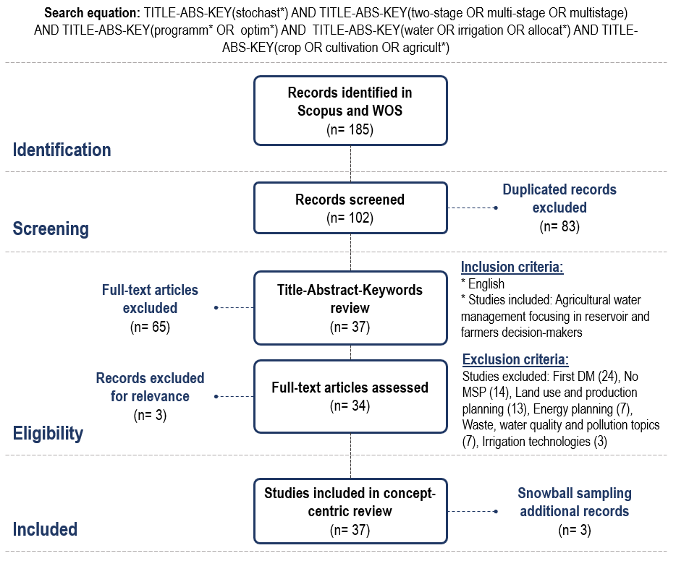

Figure 1: SLR flow chart based on the PRISMA statement (Liberati et al., 2009).

## RESULTS

### ****Review****

Mathematical modelling strategies based on MSP (including TSP) to support water management in agriculture are a topic of great awareness for academic research [64]. Such growing interest in MSP derives from the capacity for supporting optimization decisions considering system uncertain parameters modelling through a multistage decision scheme [65], the ability to provide analysis of policy scenarios of every allocation decision [66], all supported by the current rapid technological growth and the ease of incorporating this type of alternatives in decision-making. Figure 2 reflects the number of articles published related to agricultural water allocation in each country (none groups studies with no application area, only theoretical), grouping 62% of the selected articles in 2016-2021 and an average of 3.8 studies per year. Articles focus on applied case studies considering several current region conditions (89%) and hypothetical or theoretical case studies (11%) providing new modelling strategies based on MSP. China represents the country with the highest number of case studies (29 articles) due to the current country's efforts to increase agricultural productivity [67] while alleviating the water resources scarcity in arid and semi-arid zones, meeting the increased food demand, and reducing water users conflicts [22], [68]. Canada is the second country with the highest production, with an applied case study and ten studies in collaborative work with China. Guo, P, Li, Y.P, and Huang, G.H lead the scientific production with nine, nine, and eight studies and 139, 398, and 246 citations, respectively. Table 1 compiles the selected studies according to the type of study (Applied case studies-ACS, Hypothetical case studies-HCS), the research application country, and the objective addressed.

Figure 2: Cumulative distribution of articles based on the year and the country.

Table 1. Selected studies distribution

|  |  |  |  |  |
| --- | --- | --- | --- | --- |
| Case Study | Country | Objective | Citation | |
| ACS | China | Max economic benefit | [69]; [70]; [71]; [72]; [73]; [74]; [75]; [76]; [77]; [78]; [79]; [80]; [48]; [81]; [68]; [82]; [64]; [42]; [83]; [84]; [85]; [65]; [86]; [87]; [88]; [89] | |
| Max economic benefit, Min leakage loss, and Min water deficit | [39] | |
| Max the ratio between the economic benefit and crop planting area | [90] | |
| Min cost of water used while maximizing social, ecological, and benefit objectives | [91] | |
| Canada | Max economic benefit | [92] | |
| India | [93] | |
| Iran | [94] | |
| USA | [95] | |
| HCS | None* | [96]; [66]; [97]; [50] | |
| *\* Represents case studies without study areas, i.e., theoretical or hypothetical case studies.*  *Applied case studies-ACS*  *Hypothetical case studies-HCS* | | | |

### ****Guiding questions****

Answer to the first guiding question.Developing water allocation correctly in agriculture is a complex task due to the multiple uncertainties and factors that affect the optimal performance of the water system [98], [99] and decrease agricultural productivity [100]. Additionally, decision-makers must consider aspects related to the farming system, the types of crops, their characteristics, and their sensitivity to water scarcity due to their importance in supporting agricultural water productivity, thus reducing poverty and satisfying the region's food demand [65], [101]. The studies focus mainly on crops with annual life cycles (i.e., 70% of the crops studied), with wheat, corn, and rice (cereals) as the main analysed crops (Figure 3). The academic interest in this type of crop is consistent since they are grown in areas with water scarcity, high user demand, and a growing population like China [73], representing a vital pivot for its economy [102]. Besides, they are susceptible to water limitations [103] and represent one of the leading crops for achieving food security in the region and worldwide [104], [105]. The studies also address allocation problems between annual and perennial crops and conflicts between agricultural and ecological use plantations. Within the perennial crops, the main plantations concentrate fruits and berries tree types (e.g., grapes and citrus) with only four related studies, which shows the current lack of alertness of this type of plantation. Additionally, all the studies relate only to the basin manager D.M., revealing low interest in the farmer DM (with few records in irrigation scheduling using MSP) [106]–[108]) water allocation problem.

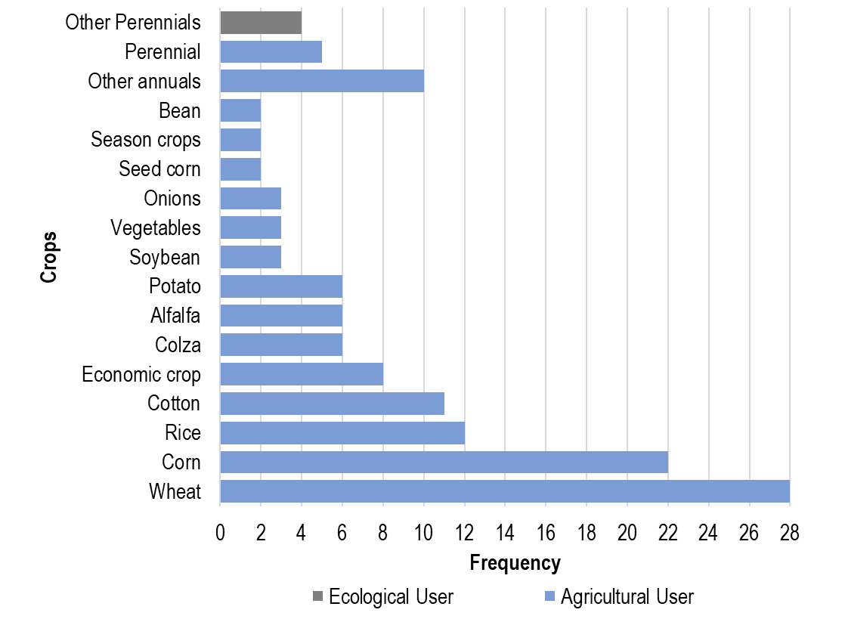

Figure 3: Analysed crops' frequency. Other annuals: Chilly, Chickpea, Melon, Mustard, Oats, Silk, Sugarcane, Sunflowers, Tomatoes, and Watermelon. Perennial: Citrus, Forest, Grapes, Grass, Nuts cotton, and Tea. Other Perennial: City greening, Farmland shelterbelts, and Woodland meadow.

**Answer to the second guiding question.** This study identifies the socio-economic, hydrological, climatic, and productive conditions as the primary sources of uncertainty for the agricultural water allocation problem. Hydrological parameters represent the primary uncertain source considering factors associated with the water cycle, the availability of water bodies (i.e., surface and groundwater), and the water circulation through the whole system (i.e., evapotranspiration, precipitation, soil moisture). The available water flow is the most frequent hydrological factor, with 24 related studies. Socio-economic parameters are the second uncertain source addressed, focusing on external factors aligned with market conditions (i.e., sale prices, benefits, and penalties), political regulations, and the study region's social context (i.e., water demands and population growth). Economic benefits and penalties are the main socio-economic parameters. Modelling these two factors as uncertain processes is essential because of their relationship with the study object and their impact on the structure and performance of the system. [72]. In contrast, studies have not adequately addressed the uncertain parameters of productive sources (e.g., production practices, productive resources, and technologies) and climatic sources (e.g., humidity, solar radiation, or temperature). This situation derives from the almost negligible impact climatic conditions have on the second decision-maker and their reduced productive aspects interventions.

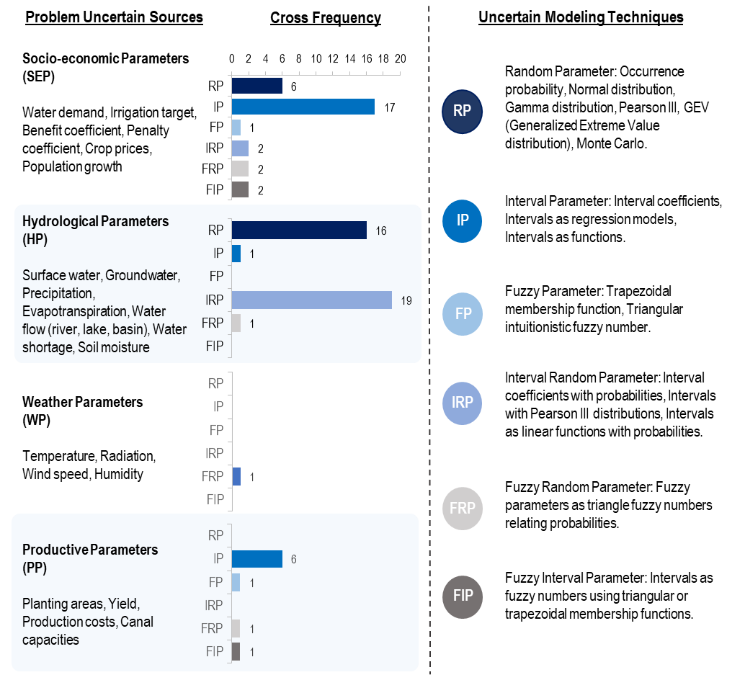

Figure 4: Frequencies of every uncertain modelling technique according to uncertain parameter sources.

There are various strategies to deal with the uncertainty factors, which depend on data availability, including quality, reliability, and the influence of subjective modelling aspects (i.e., ambiguity and vagueness) [109], [110]. With sufficient quantity and quality of the available data, researchers usually use strategies based on Random Parameters (RP) through stochastic processes (e.g., simulation models, probability, and density distribution functions) to represent the uncertainty through the parameter distribution [95]. These strategies are closely related to water flow levels and demands, with 23 retrieved studies. However, when there is a lack of data but enough reliability, the most appropriate strategy is the Interval Parameter (IP) (e.g., crisp intervals and functional intervals). This strategy allows representing the parameters considering the parameter upper and lowers bound without knowing its probability distribution [85]. On the other hand, modelling based on Fuzzy Parameters (FPa) as membership functions is the most appropriate strategy under system uncertainties related to ambiguity and vagueness [75]. IP and FPa support modelling the system's benefits, penalties, and irrigation quotas mostly.

However, several studies apply modelling strategies that use hybrid uncertain approaches regarding the uncertain parameter's form [96]. Considering that the parameter exists in a given interval and may have a related occurrence probability, certain studies combine stochastic and interval base modelling techniques (Interval Random Parameter - IRP) [78]. Similarly, the parameter may exist in a specific interval, but setting the upper and lower derives from system ambiguity. In such a situation, the interval parameters integrate the uncertain modelling through the fuzzy theory (Fuzzy Interval Parameter - FIP), which allows the representation of both values through fuzzy sets [64]. There are also processes where setting the probability of occurrence depends on fuzziness, so approaching techniques based on fuzzy theory (Fuzzy Random Parameter - FRP) allows a better representation of parameter uncertainty [66]. The most used strategy is the IRP, with 21 works, followed by the FIP and FRP. Figure 4 summarizes the primary associated uncertain sources with each modelling strategy.

**Answer to the third guiding question. T**hree main programming approaches are addressed in the agricultural water allocation problems considering the premise of uncertainty: Multistage Stochastic Programming, Interval Parameter Programming (IPP), and Fuzzy Programming (FP). Each type of programming relies on uncertain parameter modelling. MSP develops a multistage optimization framework where parameter uncertainty is revealed over time, allowing a flexible and time-adjustable decision-making process. MSP is a generalization of Two-Stage Programming where uncertainty is realized once after the first decision-making stage [111]. The TSP variant is the most implemented strategy, with 29 retrieved works. Only eight studies consider MSP due to the mathematical formulation and computational problem-solving cost regarding more optimization stages and the problem context considerations in the MSP strategy (e.g., a higher number of subsequent decisions governed by uncertainty), which currently represents one of the main barriers; besides, the IPP and FP strategies cover 27 and nine works, respectively. These programming strategies represent uncertain parameters in the objective function and constraints relying on the available data and the ambiguity involved. The IPP represents a more widely used strategy (instead of FP) due to the lack of data on different parameters in the problems and the feasibility of modelling them as intervals [39], [87]. Mixing these three types of MP allows us to answer problems where more than one form of uncertainty exists [82].

Additionally, these optimization schemes relate strategies used jointly to represent the agricultural water allocation reality and support a better decision-making tool. There are strategies aimed at addressing risk control in resource planning, such as Chance-Constraint Programming (CCP), Fuzzy-CCP, Conditional Value at Risk (CVaR), and Robust Optimization (RO). The CCP and FCCP answer stochastic and fuzzy variables in the right-hand side constraints by integrating violation probabilities in the problem [69], which relate decisions with a penalty cost associated with the feasibility of the problem, considering that each time the decision does not meet, the penalty in the decision increases [112]. The CVaR quantifies and reduces the extreme losses of economic risk caused by failures in the supply of resources considering low-probability scenarios related to uncertain and random parameters under study [70]. The RO modelling strategy introduces a function (e.g., variance) to control mainly the second-stage realizations reducing the risk in the decision and keeping the decision under a certain risk tolerance measure [80], [112]. Likewise, there are optimization structures such as Multiobjective Programming and Non-linear Programming (e.g., Quadratic Programming, Fractional Programming) considered due to more than one conflicting optimization objective and non-linear relationships in the problem structure [39], [95].

Now, relying on the complexity and strategies addressed in the water allocation problem modelling, various applicable solution strategies are associated. This work identifies three solution approaches that depend on the types of programming under uncertainty addressed. Metaheuristics and exact solution methods derive from only MSP-based models with only 2 and 3 studies, respectively. On the other hand, the mathematical model transformation approach derives from IPP or FP with the MSP framework. When the study addresses MSP with IPP, the model is usually divided into two deterministic versions of the optimization model corresponding to the lower and upper bounds [80]. When the study addresses MSP with FP jointly, the mathematical model uses alpha-cut to split the model into several deterministic models [88]. When the study addresses the three types of programming, the transformation of the stochastic model is developed in an iterative process considering alpha-cuts and cut-off points that represent the parameters' upper and lower bounds [75]. Although, the iterative process depends on the set of techniques involved and how they are related to the model's resolution. These strategies (model transformation) represent the most widely used method for solving mathematical problems. Figure 5 presents the frequency of studies that address each solution method according to the type of programming used.

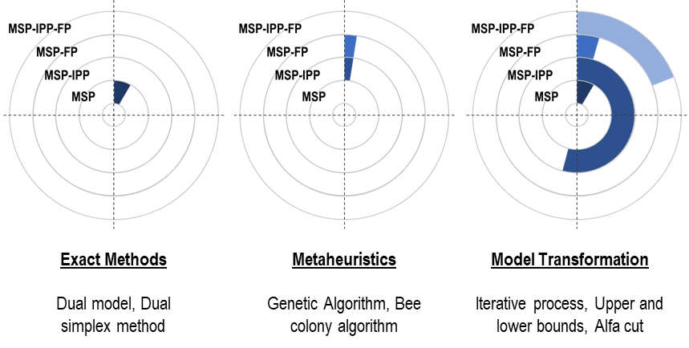

Figure 5: Frequencies of solution strategies applied regarding the MP techniques.

## FRAMEWORK

The study of factors that govern the allocation of the water resources process currently represents a relevant issue for transforming agricultural production, conserving natural resources, and assuring global food needs. An SLR allows the collecting and processing studies to support this concern by integrating mathematical programming strategies under uncertain conditions. The SLR supports building a framework proposal developing optimization models applied to agricultural water allocation under uncertain conditions. The framework relates a development flow (numbers) associated with the recommended way of addressing the water allocation problem under uncertainty, avoiding reprocessing efforts in the problem formulation and resolution. The framework holds a structure with two main sections and three related components. The Context Limitations Decisions section includes the current conditions in the problem, which describe the situation and set the modelling limitations. This section comprises the contextualization of the case study, the water decision-making levels involved, and the problem's inherent uncertain problems. On the other hand, the Modelling Decisions section relates decisions focused on the uncertain modelling strategy selection and the proper modelling problem techniques. Preliminary findings in the SLR suggest that MSP is an increasingly crucial technique for handling the complexities and uncertainties in agricultural water management. Nevertheless, selecting the MP strategy is a complex task, so this section consolidates the uncertain parameter modelling decisions, the appropriate MP strategy selection, and the consequent mathematical solution method to help researchers and practitioners define the MP- scope.

### Context Limitation Modelling Section

Case study description. The framework's first component establishes the general description of the study area, relating information to define the problem's characteristics. For this purpose, the study can relate information about the main water allocation problems (e.g., risk control, climate change, environmental impact, water use efficiency, water productivity, water quality, and pollution issues, among others). Consequently, the study must declare the study area location, the environmental and climatological conditions (i.e., temperature, humidity, solar radiation, among others), the number and type of crops (i.e., perennial or annual) considered, the hydrological characteristics of crop growth and production stages, the number of available water sources (i.e., mainly surface or underground) and the planning horizon considered in the case study. These aspects allow for establishing the current context conditions, limiting the study, and directing the research regarding the available information supporting the characterization of each case study.

Decision-makers involved. The management objectives, the demand definition, and the type of water management problem (on-farm and off-farm) differ depending on the decision-maker involved. The two upper levels address mainly off-farm management issues related to the efficiency of water supply infrastructure, canal capacities [113], and water allocation between several agricultural and non-agricultural users. The first DM must supply the resource to different users (i.e., industry, municipality, agriculture, and ecological users), and the second DM to mainly agricultural users such as farms, districts, or productive zones. On the other hand, the last DM (farmer) must provide adequate water scheme managing among crops and the production time (on-farm) [114]. To support water management, decision-makers at lower levels must escalate the requirements to support planning at the first level, reduce the risks of shortages and ensure the maximization of the system benefit. At the same time, this situation exposes a higher-risk condition associated with lower levels if improper planning occurs. Such a situation shows the significance of defining the types of decision-makers and proper water demands at each level. Accordingly, for this purpose, some available tools such as AquaCrop [71], DSSAT [108], and CropWat 8 [115] allow defining the water requirements based on the crop’s inherent conditions and the environmental conditions, supporting an appropriate estimation regarding the lower levels.

Uncertain sources. There are four primary sources of uncertainty in the agricultural water allocation problem. Each source groups different factors influenced by uncertain processes, driving decision-making difficult. The study can address factors from all sources depending on the problem scope. For example, a case study on the final decision-maker directly relates parameters from hydrological, climatic, and productive sources. However, a first-level DM study addresses parameters mainly from socio-economic and hydrological sources. Therefore, it is essential to define the sources of uncertainty to determine the available data sources (i.e., primary or secondary) related to each parameter, reduce efforts in the collection process regarding low data availability, and clarify the required tools for estimating dependent parameters (i.e., evapotranspiration, yield, irrigation quota).

### Modelling Decision Section

Uncertain modelling strategies. Using one modelling strategy over another relies on how uncertainty processes exist in the factor, the data's availability, quality, and ambiguity. Selecting the appropriate strategy is crucial because it influences a better representation of the problem and an approximation of the real solution. There are four main strategies for modelling uncertainty. A random parameter is a good strategy that depends on data availability modelling uncertainty as a random process using principally path-base [116], [117] moment matching [118], [119], and strategies based on Bootstrapping [120], [121] methods for building scenario trees that represent the parameter uncertainty. The interval Parameters strategy is helpful regarding low data availability by expressing boundaries as crisp values or functions [122] and Fuzzy Parameters under imprecision situations using fuzzy set theories [88]. On the other hand, when uncertainty exists in several forms, the study must address a mixed or hybrid strategy considering the parameter attributes [88].

Mathematical programming techniques. Establishing the types of programming affects how the study deals with the uncertainty within the programming scheme, affecting the robustness of the model. Depending on the modelling strategies of the uncertain parameters, there are related mathematical programming techniques such as Multi-stage Stochastic Programming, Interval Parameter Programming, and Fuzzy Programming. MSP (also TSP) responds to cases where uncertainty exists but in the later stages of the planning scheme, where TSP represents lower computationally cost strategies compared to MSP regarding the scenario tree related [82], but is less flexible considering only two-stage decisions [48]. Usually, the studies use three to five scenarios [65], [92], but it relies on researchers' criteria and the number of scenarios required to represent the uncertainty. On the other hand, IPP and FP comprise one-stage modelling strategies where the associated parameters respond to uncertain processes throughout the planning horizon. Planning schemes also address combined techniques considering uncertain stages realization (i.e., MSP-IPP, MSP-FP, MSP-IPP-FP), strategies for uncertain analysis, and risk control, including RO, CCP, and CVaR. Additionally, the case studies can address various objectives as non-linear behaviors in the system, reflecting the significance of integrating approaches based on MOP and NLP. Therefore, a prior in-depth understanding of the system conditions and the most suitable MP technique must exist to face every case study, supporting better water decision-making problem-solving approach.

MP solution strategies. Selecting the proper strategy will reduce the time spent getting the solution for providing the water problem optimization schemes. Three suitable solution alternatives are closely related to the type of programming under uncertainty to solve the mathematical water management model. Metaheuristics and Exact Methods comprise strategies related to the MSP approach, and Model Transformation derives from using MSP jointly with IPP or FP Metaheuristics comprise strategies such as evolutionary algorithms (i.e., Genetics Algorithms) [71] and the Bee Colony Algorithm [68]. The exact methods solutions include strategies based on the dual model [84] and the simplex method as alternatives for facing large-scale problems. Finally, Model Transformation consists of converting the original model (i.e., with uncertainties) into equivalent deterministic versions using defined bounds [72] or alpha-cut levels [88]. Model transformation is the strategy with the lowest computational cost, followed by metaheuristics and exact methods. MT also represents the proper strategy when the case study addresses the three types of programming and other optimization strategies (e.g., control measures, MOP, or NLP).

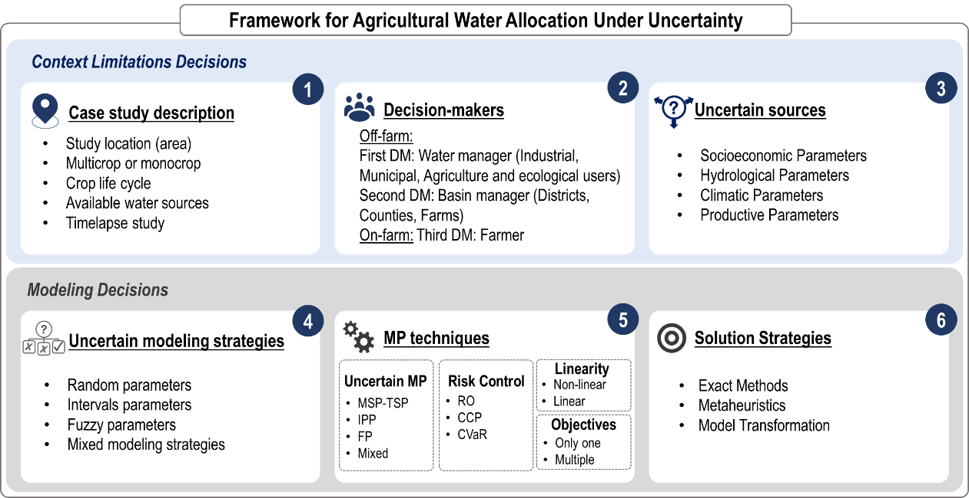

Figure 6: Framework for developing water allocation optimization models under uncertainty.

## DISCUSSION

Producing agricultural water allocation schemes is a real problem worldwide, mainly affecting areas such as arid or semi-arid regions where multiple users compete for water sources in scarcity conditions [39]. This situation derives from areas with constant but unsustainable economic development concerning the irregular natural resources available. Under such conditions, priority exists to provide the water requirements of users with the most significant impact on the economy, sustainability, and the region's productive development. However, the problem approach varies considering the types of DM involved in the case study since each DM pursues different management goals. There are three types of DM in the system: first level: water manager, second level: basin manager, and third level: farmer, where the water allocation complexity increases as the decision level decrease. Each DM faces different uncertain factors that affect the proper allocation. These factors come from various sources and represent the main problem in providing appropriate water allocation schemes considering the difficulty of modelling them. Therefore, strategies based on MP under uncertainty and supported by technological developments for collecting, processing, and modelling data denote good strategies for supporting better-supported and well-informed water allocation decisions at different system agricultural levels.

Within these strategies, MSP is a widely used MP technique worldwide to face the problem considering the multi-stage optimization structure, modelling the uncertain parameter as a random variable. Additionally, the MSP supports analysing different allocation policies and their effect mostly on maximization system benefit [84] or reducing several operation costs. However, various studies integrate the MSP with other modelling strategies regarding the multiple complexities of water systems to respond to uncertainty, support risk-control decision-making, and face several objectives and non-linear behaviours. The IPP and FP are techniques that allow the integration of parameters with unknown distributions and imprecise measurements into the structure of the MSP model, providing a higher robust decision tool. Jointly, these optimization schemes support agricultural water management under socio-economic, hydrological, climatic, and productive uncertain conditions, where modelling relies on the volume and quality of data and system imprecisions [50]. Likewise, depending on the integrated MP technique, there is an associated mathematical solution strategy (i.e., metaheuristics, exact methods, and transformation processes of the mathematical model). Considering the above, the approached modelling strategy relies mainly on the multiple types of uncertainty, the nature of uncertainty, the volume and quality of available data, the necessity to reduce risk in decisions, and the inherent characteristics of the case study problem (climatic conditions, agriculture, economic and social aspects).

On the other hand, the case studies in the SLR concentrate only on the second DM, which evidences the research interest in the basin manager considering the implications of providing good water allocation plans from a higher level to protect resources and reduce the shortage risks in the region than the farmer. Such a situation exposes the non-existent application of MSP and techniques under uncertainty to support decision-making at the lowest level, revealing a study gap that future studies must consider and cover. Thus, the lack of MSP application at the farmer's level and for perennial crops has significant implications for future research. Additionally, some crops are more critical considering the DM level, agricultural tradition, economic development, and food security. In this sense, annual crops. For instance, cereals and vegetables are more crucial than perennial ones (e.g., fruit trees) due they group crops with higher water requirements and more sensitivity under climatic conditions and water stress. Additionally, annual crops are directly related to ensuring global nutrition levels and the benefit of multiple regions, such as China, representing the country with more applied case studies in the agricultural water domain.

Moreover, there are some specific challenges and opportunity conditions in the problem that future studies should consider when developing optimal agricultural water allocation plans under uncertainty to support good water management schemes in agriculture. This work proposes seven research gaps in the agenda: (i) Keep addressing multiple optimization objectives considering that the resource must support the economy, food security, and ecosystem stability [65], [69]. (ii) Increasingly consider multiple sources of uncertainty related to water allocation problems in agriculture and climate change [86], [88]. (iii) Explore multiple forms of uncertainty [86], [90] and different uncertain parameter modelling strategies [72], [89]. (iv) Include other external factors related to crops and user water requirements (e.g., rainfall, soil moisture, evapotranspiration, and soil properties) in the whole horizon plan [64], [76], [79]. (v) To develop more effective solution strategies regarding how models under uncertainty relate to several solution complexities and large-scale problems [65], [72], [81]. (vi) Include hybrid strategies that support risk control decisions [70]. (vii) Integrate more current technological solutions for analysing and processing data that support the construction of multiple models under uncertainty, which represents the main scenario towards which research about this topic will tend to head considering the technological growth. These approaches allow for establishing a trend in future studies aimed at producing an integrated chain with the different DM analysing the conditions of each level, determining the requirements correctly, and scaling valuable and adequate information to promote better-supported water allocation schemes at every level while facing multiples optimization goals, kinds of uncertainties, risk-tolerance plans, and the integration of multiple technological tools.

Moreover, there are some specific challenges and opportunity conditions in the problem that future studies should consider when developing optimal agricultural water allocation plans under uncertainty to support good water management schemes in agriculture. This work proposes seven research gaps in the agenda: (i) Keep addressing multiple optimization objectives considering that the resource must support the economy, food security, and ecosystem stability [65], [69]. (ii) Increasingly consider multiple sources of uncertainty related to water allocation problems in agriculture and climate change [86], [88]. (iii) Explore multiple forms of uncertainty [86], [90] and different uncertain parameter modelling strategies [72], [89]. (iv) Include other external factors related to crops and user water requirements (e.g., rainfall, soil moisture, evapotranspiration, and soil properties) in the whole horizon plan [64], [76], [79]. (v) To develop more effective solution strategies regarding how models under uncertainty relate to several solution complexities and large-scale problems [65], [72], [81]. (vi) Include hybrid strategies that support risk control decisions [70]. (vii) Integrate more current technological solutions for analysing and processing data that support the construction of multiple models under uncertainty, which represents the main scenario towards which research about this topic will tend to head considering the technological growth. These approaches allow for establishing a trend in future studies aimed at producing an integrated chain with the different DM analysing the conditions of each level, determining the requirements correctly, and scaling valuable and adequate information to promote better-supported water allocation schemes at every level while facing multiples optimization goals, kinds of uncertainties, risk-tolerance plans, and the integration of multiple technological tools.

Therefore, as a synthesis and compilation of essential conclusions of the study analysis, this work proposes a methodological framework for developing optimization models under uncertainty to support agricultural water allocation into a six-step methodology relating linked stages about the formulation, development, and solution of mathematical models. This framework includes all the main aspects that researchers or decision-makers must consider for constructing optimization strategies under uncertainty, providing a guiding scheme that establishes the state of the modelling process and the decisions to allow the mathematical solution of the problem considering all the related real and theoretical case studies about water allocation optimization in agriculture. However, this work only considers scientific articles covering MSP and TSP for solving agricultural water allocation under uncertainty. Therefore, it is essential to include databases other than Scopus and Web of Science, such as Google Scholar or Science Direct, as relevant studies sources to address the problem. Then, future studies should address SLR that provide characterizations in applying the three main Mathematical Programming strategies (i.e., Interval Programming, Fuzzy Programming, and Multi-stage Stochastic Programming), allowing a better-supported agricultural water allocation modelling framework under uncertain conditions which allows for expanding the spectrum of strategies and their requirements. Besides, the studies must consider the proper water quality for agricultural crop production use, the water shortage and floods, the water-crop relationship, and the implications of the water-food-energy nexus, considering these sectors affect each other and condition water use in agriculture.

## CONCLUSIONS

This work developed a systematic literature review of peer-reviewed articles about the use of MSP to support the construction of a water allocation modelling framework in agriculture under conditions of uncertainty. The analysis shows that MSP applications and programming techniques under uncertainty in water management problems will increase, considering the importance of integrating tools that reduce risk in increasingly less predictable environments supported even more in emerging technologies. This growth will be more evident in areas where the relation between water demand, climate, and water scarcity is critical (e.g., China, India, and the Middle East and North Africa regions). Additionally, the general findings expose IPP and FP as the main optimization strategies under uncertainty applied jointly with MSP for water management problems with three primary decision levels associated with the interaction with the system. At the same time, the study identifies four primary sources of uncertainty (i.e., socio-economic, hydrological, climatic, and productive) modelled according to the volume and quality of available data. Thus, using MSP and other uncertainty techniques such as IPP and FP is vital for addressing the water management complexities in agriculture. However, the SLR shows a central research gap in applying MSP to support water allocation optimization schemes focused on farmer and perennials crops.

Therefore, based on the significance of integrating uncertainty in water decision problems, this study proposes a methodological framework to develop optimization models considering the main problem factors and the leading strategies to face uncertainty at every agricultural water allocation level. The framework comprises six components grouped into two sections describing the main aspects researchers must consider in producing models under uncertainty for water allocation in agriculture. The first section contains the problem definition decisions (i.e., context limitation decisions), and the second section contains decisions regarding uncertain modelling strategies. The framework presents a proposal flow to build every optimization model considering the analysis moment of each decision component in the problem modelling. Therefore, every late decision component depends on its respective concerns and the previous components (e.g., component two relies on component one). Hence, the framework exposes a good strategy for agricultural water allocation formulation, addressing, and solution optimization models under uncertainty since it supports the problem characterization considering the building flow process exhibited while providing the tools associated with each decision component.

## ACKNOWLEDEMENT

The Colombian Minciencias Bicentenary Grant and the Universidad Industrial de Santander (UIS) Master in Industrial Engineering research aid have fully funded this research.

## ABBREVIATIONS

|  |  |
| --- | --- |
| CCP | Chance-Constraint Programming |
| CVaR | Conditional Value at Risk |
| DM | Decision-maker |
| FCCP | Fuzzy Chance-Constraint Programming |
| FIP | Fuzzy Interval Parameter |
| FP | Fuzzy Programming |
| FPa | Fuzzy Parameter |
| FRP | Fuzzy Random Parameter |
| IP | Interval Parameter |
| IPP | Interval Parameter Programming |
| IRP | Interval Random Parameter |
| MP | Mathematical Programming |
| MSP | Multistage Stochastic Programming |
| PRISMA | Preferred Reporting Items for Systematic Reviews and Meta-Analyses |
| RO | Robust Optimization |
| RP | Random Parameter |
| SLR | Systematic Literature Review |
| TSP | Two-stage Stochastic Programming |
| WOS | Web Of Science |

## REFERENCES

1. A. K. Biswas, “Integrated water resources management: A reassessment: A water forum contribution,” *Water Int.*, vol. 29, no. 2, pp. 248–256, 2004, doi: 10.1080/02508060408691775.

2. Y. Fan, G. Huang, K. Huang, and B. W. Baetz, “Planning Water Resources Allocation under Multiple Uncertainties Through a Generalized Fuzzy Two-Stage Stochastic Programming Method,” *IEEE Trans. Fuzzy Syst.*, vol. 23, no. 5, pp. 1488–1504, 2015, doi: 10.1109/TFUZZ.2014.2362550.

3. D. P. Loucks and E. van Beek, *Water Resource Systems Modeling: Its Role in Planning and Management*. 2017. doi: 10.1007/978-3-319-44234-1_2.

4. S. L. Gebre, D. Cattrysse, and J. Van Orshoven, “Multi-Criteria Decision-Making Methods to Address Water Allocation Problems: A Systematic Review,” *Water*, vol. 13, no. 2, 2021, doi: 10.3390/w13020125.

5. L. Ji, P. Sun, Q. Ma, N. Jiang, G.-H. Huang, and Y.-L. Xie, “Inexact Two-Stage Stochastic Programming for Water Resources Allocation under Considering Demand Uncertainties and Response—A Case Study of Tianjin, China,” *Water*, vol. 9, no. 6, 2017, doi: 10.3390/w9060414.

6. FAO, “Water for Sustainable Food and Agriculture A report produced for the G20 Presidency of Germany,” 2017. Accessed: Oct. 12, 2021. [Online]. Available: www.fao.org/publications

7. V. Bjornlund and H. Bjornlund, “Understanding agricultural water management in a historical context using a socioeconomic and biophysical framework,” *Agric. Water Manag.*, vol. 213, no. November 2018, pp. 454–467, 2019, doi: 10.1016/j.agwat.2018.10.037.

8. K. Pawlak and M. Kołodziejczak, “The Role of Agriculture in Ensuring Food Security in Developing Countries: Considerations in the Context of the Problem of Sustainable Food Production,” *Sustainability*, vol. 12, no. 13, 2020, doi: 10.3390/su12135488.

9. E. A. Ainsworth, C. R. Yendrek, S. Sitch, W. J. Collins, and L. D. Emberson, “The Effects of Tropospheric Ozone on Net Primary Productivity and Implications for Climate Change,” *Annu. Rev. Plant Biol.*, vol. 63, no. 1, pp. 637–661, 2012, doi: 10.1146/annurev-arplant-042110-103829.

10. S. Kang *et al.*, “The impacts of human activities on the water–land environment of the Shiyang River basin, an arid region in northwest China / Les impacts des activités humaines sur l’environnement pédo-hydrologique du bassin de la Rivière Shiyang, une région aride du nor,” *Hydrol. Sci. J.*, vol. 49, no. 3, p. null-427, 2004, doi: 10.1623/hysj.49.3.413.54347.

11. Y. Wang, Z. Li, S. Guo, F. Zhang, and P. Guo, “A risk-based fuzzy boundary interval two-stage stochastic water resources management programming approach under uncertainty,” *J. Hydrol.*, vol. 582, no. January, p. 124553, 2020, doi: 10.1016/j.jhydrol.2020.124553.

12. Y. P. Li and G. H. Huang, “Interval-parameter Two-stage Stochastic Nonlinear Programming for Water Resources Management under Uncertainty,” *Water Resour. Manag.*, vol. 22, no. 6, pp. 681–698, 2008, doi: 10.1007/s11269-007-9186-8.

13. I. Maqsood, G. H. Huang, and J. Scott Yeomans, “An interval-parameter fuzzy two-stage stochastic program for water resources management under uncertainty,” *Eur. J. Oper. Res.*, vol. 167, no. 1, pp. 208–225, Nov. 2005, doi: 10.1016/j.ejor.2003.08.068.

14. M. N. Azaiez, “A model for conjunctive use of ground and surface water with opportunity costs,” *Eur. J. Oper. Res.*, vol. 143, no. 3, pp. 611–624, 2002, doi: 10.1016/S0377-2217(01)00339-3.

15. Y. Jiang, X. Xu, Q. Huang, Z. Huo, and G. Huang, “Optimizing regional irrigation water use by integrating a two-level optimization model and an agro-hydrological model,” *Agric. Water Manag.*, vol. 178, pp. 76–88, 2016, doi: 10.1016/j.agwat.2016.08.035.

16. Y. P. Li, G. H. Huang, S. L. Nie, and L. Liu, “Inexact multistage stochastic integer programming for water resources management under uncertainty,” *J. Environ. Manage.*, vol. 88, no. 1, pp. 93–107, 2008, doi: 10.1016/j.jenvman.2007.01.056.

17. C. Ren, Z. Li, and H. Zhang, “Integrated multi-objective stochastic fuzzy programming and AHP method for agricultural water and land optimization allocation under multiple uncertainties,” *J. Clean. Prod.*, vol. 210, pp. 12–24, 2019, doi: 10.1016/j.jclepro.2018.10.348.

18. T. Du, S. Kang, J. Zhang, and W. J. Davies, “Deficit irrigation and sustainable water-resource strategies in agriculture for China’s food security,” *J. Exp. Bot.*, vol. 66, no. 8, pp. 2253–2269, 2015, doi: 10.1093/jxb/erv034.

19. M. Li, P. Guo, and V. P. Singh, “An efficient irrigation water allocation model under uncertainty,” *Agric. Syst.*, vol. 144, pp. 46–57, 2016, doi: https://doi.org/10.1016/j.agsy.2016.02.003.

20. M. Li, Q. Fu, P. Guo, V. P. Singh, C. Zhang, and G. Yang, “Stochastic multi-objective decision making for sustainable irrigation in a changing environment,” *J. Clean. Prod.*, vol. 223, pp. 928–945, 2019, doi: https://doi.org/10.1016/j.jclepro.2019.03.183.

21. H.-Y. Zhang *et al.*, “Estimations of Water Use Efficiency in Winter Wheat Based on Multi-Angle Remote Sensing,” *Front. Plant Sci.*, vol. 12, p. 503, 2021, doi: 10.3389/fpls.2021.614417.

22. X. Li, Z. Huo, and B. Xu, “Optimal allocation method of irrigation water from river and lake by considering the fieldwater cycle process,” *Water (Switzerland)*, vol. 9, no. 12, 2017, doi: 10.3390/w9120911.

23. R. Wardlaw and J. Barnes, “Optimal allocation of irrigation water supplies in real time,” *J. Irrig. Drain. Eng.*, vol. 125, no. December, pp. 345–354, 1999.

24. C. Zhang, F. Zhang, S. Guo, X. Liu, and P. Guo, “Inexact nonlinear improved fuzzy chance-constrained programming model for irrigation water management under uncertainty,” *J. Hydrol.*, vol. 556, pp. 397–408, 2018, doi: https://doi.org/10.1016/j.jhydrol.2017.11.011.

25. A. Singh, “Land and water management planning for increasing farm income in irrigated dry areas,” *Land use policy*, vol. 42, pp. 244–250, Jan. 2015, doi: 10.1016/j.landusepol.2014.08.006.

26. M. Li, Q. Fu, V. P. Singh, D. Liu, and T. Li, “Stochastic multi-objective modeling for optimization of water-food-energy nexus of irrigated agriculture,” *Adv. Water Resour.*, vol. 127, pp. 209–224, 2019, doi: https://doi.org/10.1016/j.advwatres.2019.03.015.

27. M. Habibi Davijani, M. E. Banihabib, A. Nadjafzadeh Anvar, and S. R. Hashemi, “Multi-Objective Optimization Model for the Allocation of Water Resources in Arid Regions Based on the Maximization of Socioeconomic Efficiency,” *Water Resour. Manag.*, vol. 30, no. 3, pp. 927–946, 2016, doi: 10.1007/s11269-015-1200-y.

28. Y. Tang, F. Zhang, S. Wang, X. Zhang, S. Guo, and P. Guo, “A distributed interval nonlinear multiobjective programming approach for optimal irrigation water management in an arid area,” *Agric. Water Manag.*, vol. 220, pp. 13–26, 2019, doi: https://doi.org/10.1016/j.agwat.2019.03.052.

29. G. Schoups, C. L. Addams, J. L. Minjares, and S. M. Gorelick, “Sustainable conjunctive water management in irrigated agriculture: Model formulation and application to the Yaqui Valley, Mexico,” *Water Resour. Res.*, vol. 42, no. 10, 2006, doi: https://doi.org/10.1029/2006WR004922.

30. X. Li, C. Zhang, Z. Huo, and A. J. Adeloye, “A sustainable irrigation water management framework coupling water-salt processes simulation and uncertain optimization in an arid area,” *Agric. Water Manag.*, vol. 231, p. 105994, 2020, doi: https://doi.org/10.1016/j.agwat.2019.105994.

31. M. García-Vila and E. Fereres, “Combining the simulation crop model AquaCrop with an economic model for the optimization of irrigation management at farm level,” *Eur. J. Agron.*, vol. 36, no. 1, pp. 21–31, 2012, doi: https://doi.org/10.1016/j.eja.2011.08.003.

32. Y. Wang, S. Guo, Q. Yue, X. Mao, and P. Guo, “Distributed AquaCrop simulation-nonlinear multi-objective dependent-chance programming for irrigation water resources management under uncertainty,” *Agric. Water Manag.*, vol. 247, p. 106752, 2021, doi: https://doi.org/10.1016/j.agwat.2021.106752.

33. K. Cheng, S. Wei, Y. Ren, and Q. Fu, “Optimal allocation of agricultural water resources under the background of China’s agricultural water price reform-a case study of Heilongjiang province,” *Appl. Math. Model.*, vol. 97, pp. 636–649, 2021, doi: https://doi.org/10.1016/j.apm.2021.04.019.

34. T. W. Archibald and S. E. Marshall, “Review of Mathematical Programming Applications in Water Resource Management Under Uncertainty,” *Environ. Model. Assess.*, vol. 23, no. 6, pp. 753–777, 2018, doi: 10.1007/s10666-018-9628-0.

35. A. Singh, “Irrigation Planning and Management Through Optimization Modelling,” *Water Resour. Manag.*, vol. 28, no. 1, pp. 1–14, 2014, doi: 10.1007/s11269-013-0469-y.

36. D. Liu *et al.*, “A macro-evolutionary multi-objective immune algorithm with application to optimal allocation of water resources in Dongjiang River basins, South China,” *Stoch. Environ. Res. Risk Assess.*, vol. 26, no. 4, pp. 491–507, 2012, doi: 10.1007/s00477-011-0505-5.

37. R. Lalehzari, S. Boroomand Nasab, H. Moazed, and A. Haghighi, “Multiobjective Management of Water Allocation to Sustainable Irrigation Planning and Optimal Cropping Pattern,” *J. Irrig. Drain. Eng.*, vol. 142, no. 1, p. 05015008, 2016, doi: 10.1061/(asce)ir.1943-4774.0000933.

38. M. Li and P. Guo, “A multi-objective optimal allocation model for irrigation water resources under multiple uncertainties,” *Appl. Math. Model.*, vol. 38, no. 19, pp. 4897–4911, 2014, doi: https://doi.org/10.1016/j.apm.2014.03.043.

39. F. Zhang, P. Guo, B. A. Engel, S. Guo, C. Zhang, and Y. Tang, “Planning seasonal irrigation water allocation based on an interval multiobjective multi-stage stochastic programming approach,” *Agric. Water Manag.*, vol. 223, no. 17, p. 105692, 2019, doi: 10.1016/j.agwat.2019.105692.

40. D. G. Regulwar and J. B. Gurav, “Irrigation Planning Under Uncertainty-A Multi Objective Fuzzy Linear Programming Approach,” *Water Resour. Manag.*, vol. 25, no. 5, pp. 1387–1416, 2011, doi: 10.1007/s11269-010-9750-5.

41. C. Chen, G. H. Huang, Y. P. Li, and Y. Zhou, “A robust risk analysis method for water resources allocation under uncertainty,” *Stoch. Environ. Res. Risk Assess.*, vol. 27, no. 3, pp. 713–723, 2013, doi: 10.1007/s00477-012-0634-5.

42. M. Li, P. Guo, V. P. Singh, and J. Zhao, “Irrigation Water Allocation Using an Inexact Two-Stage Quadratic Programming with Fuzzy Input under Climate Change,” *J. Am. Water Resour. Assoc.*, vol. 52, no. 3, pp. 667–684, 2016, doi: 10.1111/1752-1688.12415.

43. J. A. Delgado, N. M. Short, D. P. Roberts, and B. Vandenberg, “Big Data Analysis for Sustainable Agriculture on a Geospatial Cloud Framework,” *Front. Sustain. Food Syst.*, vol. 3, no. July, 2019, doi: 10.3389/fsufs.2019.00054.

44. A. Rokade, M. Singh, P. K. Malik, R. Singh, and T. Alsuwian, “Intelligent Data Analytics Framework for Precision Farming Using IoT and Regressor Machine Learning Algorithms,” *Appl. Sci.*, vol. 12, no. 19, 2022, doi: 10.3390/app12199992.

45. E. A. Abioye *et al.*, “Precision Irrigation Management Using Machine Learning and Digital Farming Solutions,” *AgriEngineering*, vol. 4, no. 1, pp. 70–103, 2022, doi: 10.3390/agriengineering4010006.

46. S. Amani and H. Shafizadeh-Moghadam, “A review of machine learning models and influential factors for estimating evapotranspiration using remote sensing and ground-based data,” *Agric. Water Manag.*, vol. 284, no. April, p. 108324, 2023, doi: 10.1016/j.agwat.2023.108324.

47. C. Fathy and H. M. Ali, “A Secure IoT-Based Irrigation System for Precision Agriculture Using the Expeditious Cipher,” *Sensors*, vol. 23, no. 4, pp. 1–16, 2023, doi: 10.3390/s23042091.

48. Q. Q. Li, Y. P. Li, G. H. Huang, and C. X. Wang, “Risk aversion based interval stochastic programming approach for agricultural water management under uncertainty,” *Stoch. Environ. Res. Risk Assess.*, vol. 32, no. 3, pp. 715–732, 2018, doi: 10.1007/s00477-017-1490-0.

49. Y. P. Li and G. H. Huang, “Interval-parameter robust optimization for environmental management under uncertainty,” *Can. J. Civ. Eng.*, vol. 36, no. 4, pp. 592–606, 2009, doi: 10.1139/L08-131.

50. I. Maqsood, G. Huang, Y. Huang, and B. Chen, “ITOM: An interval-parameter two-stage optimization model for stochastic planning of water resources systems,” *Stoch. Environ. Res. Risk Assess.*, vol. 19, no. 2, pp. 125–133, 2005, doi: 10.1007/s00477-004-0220-6.

51. G. H. Huang and D. P. Loucks, “An inexact two-stage stochastic programming model for water resources management under uncertainty,” *Civ. Eng. Environ. Syst.*, vol. 17, no. 2, pp. 95–118, 2000, doi: 10.1080/02630250008970277.

52. L. Ji, T. Wu, Y. Xie, G. Huang, and L. Sun, “A novel two-stage fuzzy stochastic model for water supply management from a water-energy nexus perspective,” *J. Clean. Prod.*, vol. 277, p. 123386, 2020, doi: 10.1016/j.jclepro.2020.123386.

53. Y. P. Li, G. H. Huang, and S. L. Nie, “An interval-parameter multi-stage stochastic programming model for water resources management under uncertainty,” *Adv. Water Resour.*, vol. 29, no. 5, pp. 776–789, 2006, doi: 10.1016/j.advwatres.2005.07.008.

54. M. Niazi, “Do Systematic Literature Reviews Outperform Informal Literature Reviews in the Software Engineering Domain? An Initial Case Study,” *Arab. J. Sci. Eng.*, vol. 40, no. 3, pp. 845–855, 2015, doi: 10.1007/s13369-015-1586-0.

55. P. Kaur, A. Dhir, A. Tandon, E. A. Alzeiby, and A. A. Abohassan, “A systematic literature review on cyberstalking. An analysis of past achievements and future promises,” *Technol. Forecast. Soc. Change*, vol. 163, no. October 2020, p. 120426, 2021, doi: 10.1016/j.techfore.2020.120426.

56. Y. Xiao and M. Watson, “Guidance on Conducting a Systematic Literature Review,” *J. Plan. Educ. Res.*, vol. 39, no. 1, pp. 93–112, 2019, doi: 10.1177/0739456X17723971.

57. H. Arksey and L. O’Malley, “Scoping studies: Towards a methodological framework,” *Int. J. Soc. Res. Methodol. Theory Pract.*, vol. 8, no. 1, pp. 19–32, 2005, doi: 10.1080/1364557032000119616.

58. A. Liberati *et al.*, “The PRISMA statement for reporting systematic reviews and meta-analyses of studies that evaluate health care interventions: explanation and elaboration,” *J. Clin. Epidemiol.*, vol. 62, no. 10, pp. e1–e34, 2009, doi: 10.1016/j.jclinepi.2009.06.006.

59. M. Irshad, K. Petersen, and S. Poulding, “A systematic literature review of software requirements reuse approaches,” *Inf. Softw. Technol.*, vol. 93, no. September 2017, pp. 223–245, 2018, doi: 10.1016/j.infsof.2017.09.009.

60. J. Webster and R. T. Watson, “Analyzing the Past to Prepare for the Future: Writing a Literature Review,” *MIS Q.*, vol. 26, no. 2, pp. xiii--xxiii, 2002, [Online]. Available: http://www.jstor.org/stable/4132319

61. A. W. Harzing and S. Alakangas, “Google Scholar, Scopus and the Web of Science: a longitudinal and cross-disciplinary comparison,” *Scientometrics*, vol. 106, no. 2, pp. 787–804, 2016, doi: 10.1007/s11192-015-1798-9.

62. M. E. Falagas, E. I. Pitsouni, G. A. Malietzis, and G. Pappas, “Comparison of PubMed, Scopus, Web of Science, and Google Scholar: strengths and weaknesses,” *FASEB J.*, vol. 22, no. 2, pp. 338–342, 2008, doi: 10.1096/fj.07-9492lsf.

63. N. Bakkalbasi, K. Bauer, J. Glover, and L. Wang, “Three options for citation tracking: Google Scholar, Scopus and Web of Science,” *Biomed. Digit. Libr.*, vol. 3, no. 2003, pp. 1–8, 2006, doi: 10.1186/1742-5581-3-7.

64. G. Niu, Y. P. Li, G. H. Huang, J. Liu, and Y. R. Fan, “Crop planning and water resource allocation for sustainable development of an irrigation region in China under multiple uncertainties,” *Agric. Water Manag.*, vol. 166, pp. 53–69, 2016, doi: 10.1016/j.agwat.2015.12.011.

65. Z. Y. Dai and Y. P. Li, “A multistage irrigation water allocation model for agricultural land-use planning under uncertainty,” *Agric. Water Manag.*, vol. 129, pp. 69–79, 2013, doi: 10.1016/j.agwat.2013.07.013.

66. P. Guo, G. H. Huang, and Y. P. Li, “Inexact fuzzy-stochastic programming for water resources management under multiple uncertainties,” *Environ. Model. Assess.*, vol. 15, no. 2, pp. 111–124, 2010, doi: 10.1007/s10666-009-9194-6.

67. Y. Xu, J. Li, and J. Wan, “Agriculture and crop science in China: Innovation and sustainability,” *Crop J.*, vol. 5, no. 2, pp. 95–99, Apr. 2017, doi: 10.1016/J.CJ.2017.02.002.

68. S. Chen, D. Shao, W. Gu, B. Xu, H. Li, and L. Fang, “An interval multistage water allocation model for crop different growth stages under inputs uncertainty,” *Agric. Water Manag.*, vol. 186, pp. 86–97, 2017, doi: 10.1016/j.agwat.2017.03.001.

69. W. Youzhi, F. Alexander, and G. Ping, “A model integrating the system dynamic model with the risk based two-stage stochastic robust programming model for agricultural-ecological water resources management,” *Stoch. Environ. Res. Risk Assess.*, vol. 8, 2021, doi: 10.1007/s00477-021-01972-8.

70. W. J. Zhang, Q. Tan, and T. Y. Zhang, “A risk-averse stochastic quadratic model with recourse for supporting irrigation water management in uncertain and nonlinear environments,” *Agric. Water Manag.*, vol. 244, no. March 2020, p. 106431, 2021, doi: 10.1016/j.agwat.2020.106431.

71. Y. Wang and P. Guo, “Irrigation water resources optimization with consideration of the regional agro-hydrological process of crop growth and multiple uncertainties,” *Agric. Water Manag.*, vol. 245, p. 106630, 2021, doi: 10.1016/j.agwat.2020.106630.

72. M. Li, Q. Fu, V. P. Singh, D. Liu, and X. Gong, “Risk-based agricultural water allocation under multiple uncertainties,” *Agric. Water Manag.*, vol. 233, no. February, 2020, doi: 10.1016/j.agwat.2020.106105.

73. L. Ji, B. Zhang, G. Huang, and Y. Lu, “Multi-stage stochastic fuzzy random programming for food-water-energy nexus management under uncertainties,” *Resour. Conserv. Recycl.*, vol. 155, no. September 2019, p. 104665, 2020, doi: 10.1016/j.resconrec.2019.104665.

74. M. Suo, F. Du, Y. Li, T. Kong, and J. Zhang, “An Inexact Inventory Theory-Based Water Resources Distribution Model for Yuecheng Reservoir, China,” *Math. Probl. Eng.*, vol. 2020, 2020, doi: 10.1155/2020/6273513.

75. S. Guo, F. Zhang, C. Zhang, Y. Wang, and P. Guo, “An improved intuitionistic fuzzy interval two-stage stochastic programming for resources planning management integrating recourse penalty from resources scarcity and surplus,” *J. Clean. Prod.*, vol. 234, pp. 185–199, 2019, doi: 10.1016/j.jclepro.2019.06.183.

76. C. Zhang, Q. Yue, and P. Guo, “A nonlinear inexact two-stage management model for agricultural water allocation under uncertainty based on the heihe river water diversion plan,” *Int. J. Environ. Res. Public Health*, vol. 16, no. 11, 2019, doi: 10.3390/ijerph16111884.

77. S. Chen, J. Xu, Q. Li, X. Tan, and X. Nong, “A copula-based interval-bistochastic programming method for regional water allocation under uncertainty,” *Agric. Water Manag.*, vol. 217, no. October 2017, pp. 154–164, 2019, doi: 10.1016/j.agwat.2019.02.008.

78. C. Zhang and P. Guo, “An inexact CVaR two-stage mixed-integer linear programming approach for agricultural water management under uncertainty considering ecological water requirement,” *Ecol. Indic.*, vol. 92, pp. 342–353, 2018, doi: 10.1016/j.ecolind.2017.02.018.

79. Z. Yan and M. Li, “A stochastic optimization model for agricultural irrigation water allocation based on the field water cycle,” *Water (Switzerland)*, vol. 10, no. 8, 2018, doi: 10.3390/w10081031.

80. Q. Fu, T. Li, S. Cui, D. Liu, and X. Lu, “Agricultural Multi-Water Source Allocation Model Based on Interval Two-Stage Stochastic Robust Programming under Uncertainty,” *Water Resour. Manag.*, vol. 32, no. 4, pp. 1261–1274, 2018, doi: 10.1007/s11269-017-1868-2.

81. C. Zhang, M. Li, and P. Guo, “An interval multistage joint-probabilistic chance-constrained programming model with left-hand-side randomness for crop area planning under uncertainty,” *J. Clean. Prod.*, vol. 167, pp. 1276–1289, 2017, doi: 10.1016/j.jclepro.2017.05.191.

82. J. Liu, Y. P. Li, G. H. Huang, X. W. Zhuang, and H. Y. Fu, “Assessment of uncertainty effects on crop planning and irrigation water supply using a Monte Carlo simulation based dual-interval stochastic programming method,” *J. Clean. Prod.*, vol. 149, pp. 945–967, 2017, doi: 10.1016/j.jclepro.2017.02.100.

83. M. Li, P. Guo, L. Zhang, and J. Zhao, “Multi-dimensional critical regulation control modes and water optimal allocation for irrigation system in the middle reaches of Heihe River basin, China,” *Ecol. Eng.*, vol. 76, pp. 166–177, 2015, doi: 10.1016/j.ecoleng.2014.03.036.

84. L. Cui, Y. Li, and G. Huang, “Planning an agricultural water resources management system: A two-stage stochastic fractional programming model,” *Sustain.*, vol. 7, no. 8, pp. 9846–9863, 2015, doi: 10.3390/su7089846.

85. X. Li, H. Lu, L. He, and B. Shi, “An inexact stochastic optimization model for agricultural irrigation management with a case study in China,” *Stoch. Environ. Res. Risk Assess.*, vol. 28, no. 2, pp. 281–295, 2014, doi: 10.1007/s00477-013-0748-4.

86. Y. Zhu, Y. P. Li, G. H. Huang, and L. Guo, “Risk assessment of agricultural irrigation water under interval functions,” *Stoch. Environ. Res. Risk Assess.*, vol. 27, no. 3, pp. 693–704, 2013, doi: 10.1007/s00477-012-0632-7.

87. Y. Huang, Y. P. Li, X. Chen, and Y. G. Ma, “Optimization of the irrigation water resources for agricultural sustainability in Tarim River Basin, China,” *Agric. Water Manag.*, vol. 107, pp. 74–85, 2012, doi: 10.1016/j.agwat.2012.01.012.

88. Y. P. Li and G. H. Huang, “Planning agricultural water resources system associated with fuzzy and random features,” *J. Am. Water Resour. Assoc.*, vol. 47, no. 4, pp. 841–860, 2011, doi: 10.1111/j.1752-1688.2011.00558.x.

89. W. Li, Y. P. Li, C. H. Li, and G. H. Huang, “An inexact two-stage water management model for planning agricultural irrigation under uncertainty,” *Agric. Water Manag.*, vol. 97, no. 11, pp. 1905–1914, 2010, doi: 10.1016/j.agwat.2010.07.005.

90. C. Zhang, M. Li, and P. Guo, “Two-Stage Stochastic Chance-Constrained Fractional Programming Model for Optimal Agricultural Cultivation Scale in an Arid Area,” *J. Irrig. Drain. Eng.*, vol. 143, no. 9, p. 05017006, 2017, doi: 10.1061/(asce)ir.1943-4774.0001216.

91. Q. Fu, J. Li, T. Li, D. Liu, and S. Cui, “Utilization threshold of surface water and groundwater based on the system optimization of crop planting structure,” *Front. Agric. Sci. Eng.*, vol. 3, no. 3, pp. 231–240, 2016, doi: 10.15302/J-FASE-2016101.

92. H. W. Lu, G. H. Huang, and L. He, “An inexact programming method for agricultural irrigation systems under parameter uncertainty,” *Stoch. Environ. Res. Risk Assess.*, vol. 23, no. 6, pp. 759–768, 2009, doi: 10.1007/s00477-008-0256-0.

93. Y. S. Muhammad and G. C. Pflug, “Stochastic vs deterministic programming in water management: the value of flexibility,” *Ann. Oper. Res.*, vol. 223, no. 1, pp. 309–328, 2014, doi: 10.1007/s10479-013-1455-8.

94. L. Amanat Behbahani, M. Moghaddasi, H. Ebrahimi, and H. Babazadeh, “Optimal water allocation and distribution management in irrigation networks under uncertainty by multi-stage stochastic case study: Irrigation and drainage networks of Maroon*,” *Irrig. Drain.*, vol. 69, no. 4, pp. 531–545, 2020, doi: 10.1002/ird.2476.

95. G. F. Marques, J. R. Lund, and R. E. Howitt, “Modeling Conjunctive Use Operations and Farm Decisions with Two-Stage Stochastic Quadratic Programming,” *J. Water Resour. Plan. Manag.*, vol. 136, no. 3, pp. 386–394, 2010, doi: 10.1061/(asce)wr.1943-5452.0000045.

96. X. Xin, G. Huang, W. Sun, Y. Zhou, and Y. Fan, “Factorial Two-Stage Irrigation System Optimization Model,” *J. Irrig. Drain. Eng.*, vol. 142, no. 2, p. 04015056, 2016, doi: 10.1061/(asce)ir.1943-4774.0000951.

97. H. Lu, G. Huang, and L. He, “Inexact rough-interval two-stage stochastic programming for conjunctive water allocation problems,” *J. Environ. Manage.*, vol. 91, no. 1, pp. 261–269, 2009, doi: 10.1016/j.jenvman.2009.08.011.

98. J. Hou, X. Fan, and R. Liu, “Optimal spatial allocation of irrigation water under uncertainty using the bilayer nested optimisation algorithm and geospatial technology,” *Int. J. Geogr. Inf. Sci.*, vol. 30, no. 12, pp. 2462–2485, 2016, doi: 10.1080/13658816.2016.1181264.

99. M. Samian, K. N. Mahdei, H. Saadi, and R. Movahedi, “Identifying factors affecting optimal management of agricultural water,” *J. Saudi Soc. Agric. Sci.*, vol. 14, no. 1, pp. 11–18, 2015, doi: 10.1016/j.jssas.2014.01.001.

100. S. Kang *et al.*, “Improving agricultural water productivity to ensure food security in China under changing environment: From research to practice,” *Agric. Water Manag.*, vol. 179, pp. 5–17, 2017, doi: 10.1016/j.agwat.2016.05.007.

101. J. Zhao, M. Li, P. Guo, C. Zhang, and Q. Tan, “Agricultural water productivity oriented water resources allocation based on the coordination of multiple factors,” *Water (Switzerland)*, vol. 9, no. 7, 2017, doi: 10.3390/w9070490.

102. X. Li *et al.*, “Patterns of cereal yield growth across China from 1980 to 2010 and their implications for food production and food security,” *PLoS One*, vol. 11, no. 7, pp. 1–18, 2016, doi: 10.1371/journal.pone.0159061.

103. T. Du, S. Kang, J. Sun, X. Zhang, and J. Zhang, “An improved water use efficiency of cereals under temporal and spatial deficit irrigation in north China,” *Agric. Water Manag.*, vol. 97, no. 1, pp. 66–74, 2010, doi: 10.1016/j.agwat.2009.08.011.

104. B. Shiferaw, M. Smale, H. J. Braun, E. Duveiller, M. Reynolds, and G. Muricho, “Crops that feed the world 10. Past successes and future challenges to the role played by wheat in global food security,” *Food Secur.*, vol. 5, no. 3, pp. 291–317, 2013, doi: 10.1007/s12571-013-0263-y.

105. U. Grote, A. Fasse, T. T. Nguyen, and O. Erenstein, “Food Security and the Dynamics of Wheat and Maize Value Chains in Africa and Asia,” *Front. Sustain. Food Syst.*, vol. 4, no. February, pp. 1–17, 2021, doi: 10.3389/fsufs.2020.617009.

106. Q. Li and G. Hu, “Multistage stochastic programming modeling for farmland irrigation management under uncertainty,” *PLoS One*, vol. 15, no. 6, pp. 1–21, 2020, doi: 10.1371/journal.pone.0233723.

107. A. Jamal, R. Linker, and M. Housh, “Comparison of Various Stochastic Approaches for Irrigation Scheduling Using Seasonal Climate Forecasts,” *J. Water Resour. Plan. Manag.*, vol. 144, no. 7, p. 04018028, 2018, doi: 10.1061/(asce)wr.1943-5452.0000951.

108. R. Linker, “Stochastic model-based optimization of irrigation scheduling,” *Agric. Water Manag.*, vol. 243, no. August 2020, p. 106480, 2021, doi: 10.1016/j.agwat.2020.106480.

109. Q. Fu *et al.*, “An interval parameter conditional value-at-risk two-stage stochastic programming model for sustainable regional water allocation under different representative concentration pathways scenarios,” *J. Hydrol.*, vol. 564, no. April, pp. 115–124, 2018, doi: 10.1016/j.jhydrol.2018.07.008.

110. Y. Wang, Z. Li, S. Guo, F. Zhang, and P. Guo, “A risk-based fuzzy boundary interval two-stage stochastic water resources management programming approach under uncertainty,” *J. Hydrol.*, vol. 582, no. August 2019, p. 124553, 2020, doi: 10.1016/j.jhydrol.2020.124553.

111. C. Li and I. E. Grossmann, “A Review of Stochastic Programming Methods for Optimization of Process Systems Under Uncertainty,” *Front. Chem. Eng.*, vol. 2, no. January, pp. 1–20, 2021, doi: 10.3389/fceng.2020.622241.

112. N. V Sahinidis, “Optimization under uncertainty: state-of-the-art and opportunities,” *Comput. Chem. Eng.*, vol. 28, no. 6, pp. 971–983, 2004, doi: https://doi.org/10.1016/j.compchemeng.2003.09.017.

113. M. Orojloo, S. M. Hashemy Shahdany, and A. Roozbahani, “Developing an integrated risk management framework for agricultural water conveyance and distribution systems within fuzzy decision making approaches,” *Sci. Total Environ.*, vol. 627, pp. 1363–1376, 2018, doi: https://doi.org/10.1016/j.scitotenv.2018.01.324.

114. F. Zhang, S. Guo, X. Liu, Y. Wang, B. A. Engel, and P. Guo, “Towards sustainable water management in an arid agricultural region: A multi-level multi-objective stochastic approach,” *Agric. Syst.*, vol. 182, no. 17, p. 102848, 2020, doi: 10.1016/j.agsy.2020.102848.

115. M. E. Gabr and E. M. Fattouh, “Assessment of irrigation management practices using FAO-CROPWAT 8, case studies: Tina Plain and East South El-Kantara, Sinai, Egypt,” *Ain Shams Eng. J.*, vol. 12, no. 2, pp. 1623–1636, 2021, doi: https://doi.org/10.1016/j.asej.2020.09.017.

116. J. Dupačová, G. Consigli, and S. W. Wallace, “Scenarios for Multistage Stochastic Programs,” *Ann. Oper. Res.*, vol. 100, no. 1, pp. 25–53, 2000, doi: 10.1023/A:1019206915174.

117. S. Mitra, S. Lim, and A. Karathanasopoulos, “Regression based scenario generation: Applications for performance management,” *Oper. Res. Perspect.*, vol. 6, p. 100095, 2019, doi: https://doi.org/10.1016/j.orp.2018.100095.

118. K. Høyland, M. Kaut, and S. W. Wallace, “A Heuristic for Moment-Matching Scenario Generation,” *Comput. Optim. Appl.*, vol. 24, no. 2, pp. 169–185, 2003, doi: 10.1023/A:1021853807313.

119. K. Høyland and S. W. Wallace, “Generating Scenario Trees for Multistage Decision Problems,” *Manage. Sci.*, vol. 47, no. 2, pp. 295–307, Feb. 2001, doi: 10.1287/mnsc.47.2.295.9834.

120. J. Prairie, K. Nowak, B. Rajagopalan, U. Lall, and T. Fulp, “A stochastic nonparametric approach for streamflow generation combining observational and paleoreconstructed data,” *Water Resour. Res.*, vol. 44, no. 6, 2008, doi: https://doi.org/10.1029/2007WR006684.

121. W. J. Raseman, B. Rajagopalan, J. R. Kasprzyk, and W. Kleiber, “Nearest neighbor time series bootstrap for generating influent water quality scenarios,” *Stoch. Environ. Res. Risk Assess.*, vol. 34, no. 1, pp. 23–31, 2020, doi: 10.1007/s00477-019-01762-3.

122. D. Pal and G. S. Mahapatra, “Parametric Functional Representation of Interval Number with Arithmetic Operations,” *Int. J. Appl. Comput. Math.*, vol. 3, no. 2, pp. 459–469, 2017, doi: 10.1007/s40819-015-0113-z.

1. Corresponding author